**RESTAURANT ORDERS ANALYSIS**

A quarter's worth of orders from a fictitious restaurant serving international cuisine, including the date and time of each order, the items ordered, and additional details on the type, name and price of the items.

Recommended Analysis

1.View the menu_items table and write a query to find the number of items on the menu

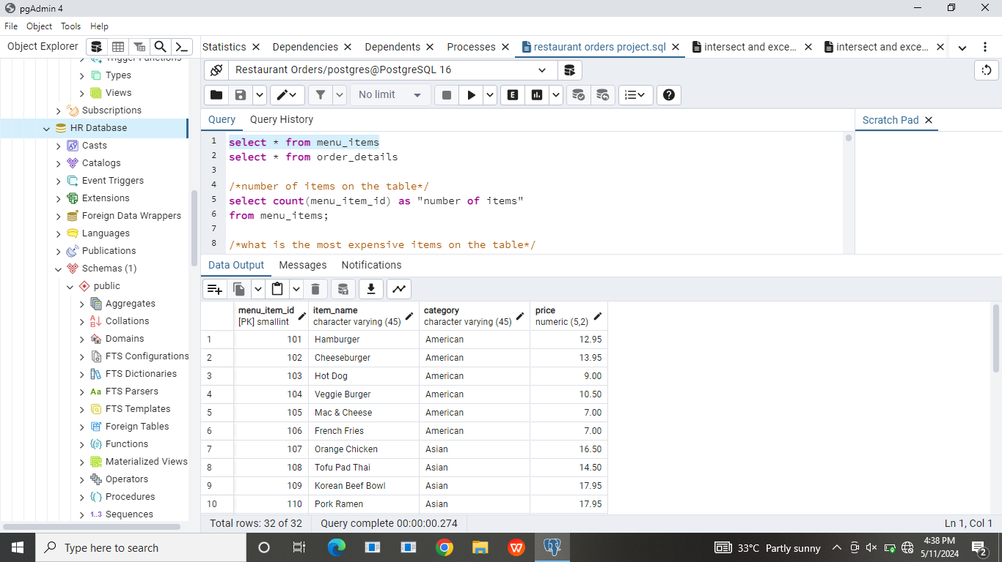

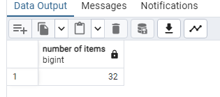

2.What are the least and most expensive items on the menu?

Most expensive item

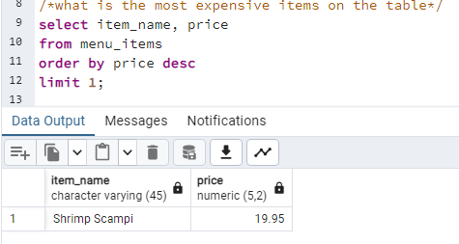

Least expensive item

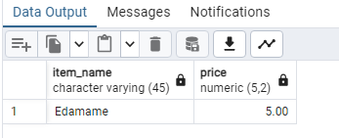

3.How many Italian dishes are on the menu? What are the least and most expensive Italian dishes on the menu?

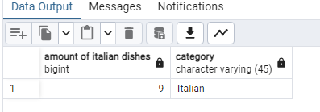

Most expensive Italian dish

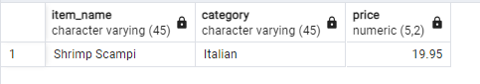

Least expensive Italian dish

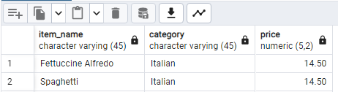

4.How many dishes are in each category? What is the average dish price within each category?

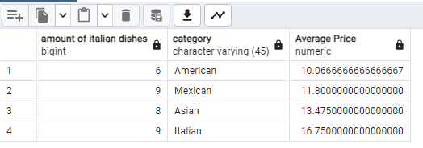

5.View the order_details table. What is the date range of the table?

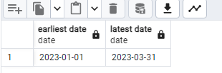

6.How many orders were made within this date range? How many items were ordered within this date range?

Amount of orders

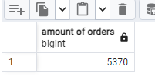

Amount of ordered items

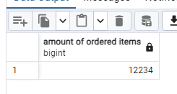

7.Which orders had the most number of items?

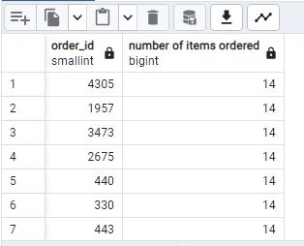

8.How many orders had more than 12 items?

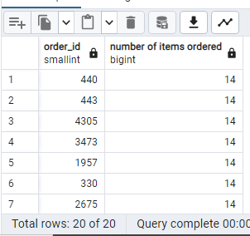

9.Combine the menu_items and order_details tables into a single table

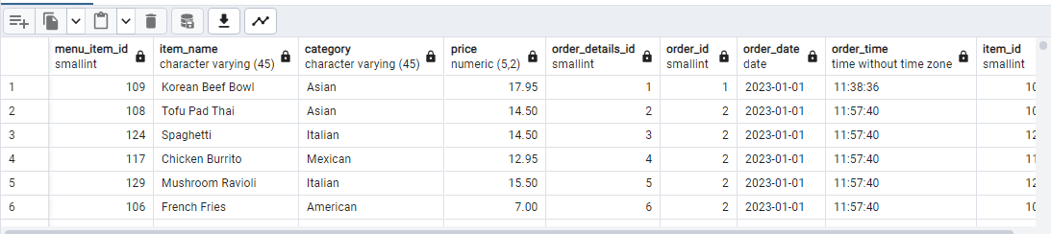

10.What were the least and most ordered items? What categories were they in?

Most ordered item

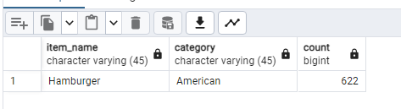

Least ordered item

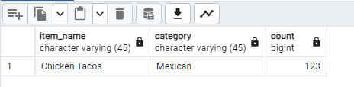

11.What were the top 5 orders that spent the most money?

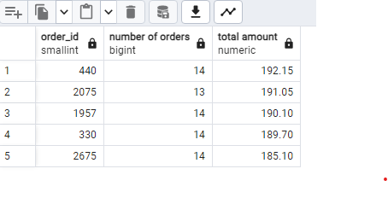

12.View the details of the highest spend order. Which specific items were purchased?

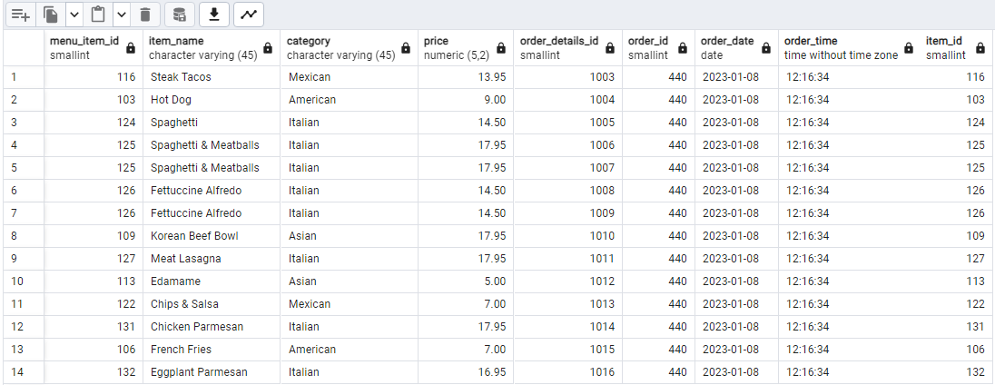

13.View the details of the top 5 highest spend orders

